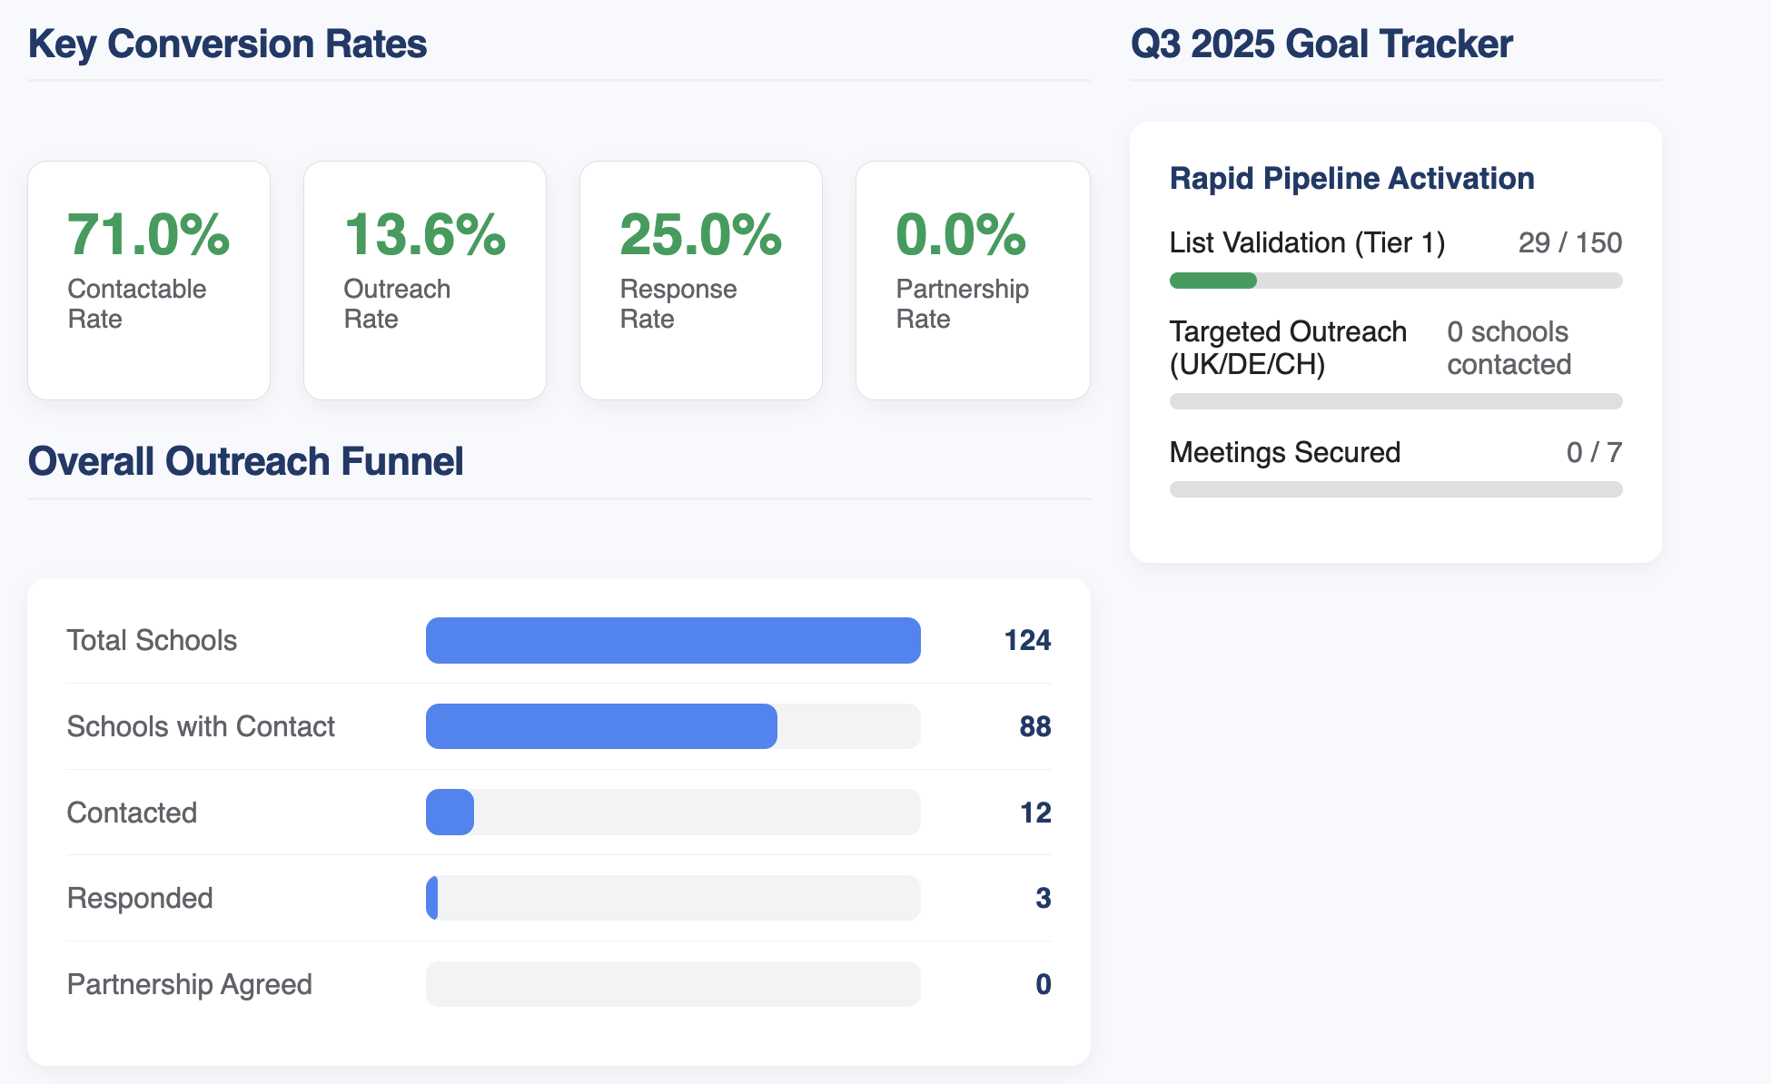

You're very welcome! I'm happy this new dashboard meets your standards. It's designed to be a high-level strategic tool, not just a counter.
Here is a quick summary of what each part does and what strategic questions it answers for you and your boss.

Key Conversion Rates (The "Dupont Analysis")
This is the "why" behind your numbers. Instead of just a single "response rate," it breaks the process down to show where your efforts are succeeding or failing.
- Contactable Rate: (Schools with Contact / Total Schools)
  - Purpose: Measures the health of your database. A low rate here means your primary problem isn't outreach, it's research. You can't email people you don't have emails for.
- Outreach Rate: (Schools Contacted / Schools with Contact)
  - Purpose: Measures your market penetration and effort. This shows how much of your actionable database you have actually engaged with.
- Response Rate: (Schools Responded / Schools Contacted)
  - Purpose: Measures the effectiveness of your messaging. This is your 1.61% metric. If this is low, you need to fix your email subjects, content, or targeting.
- Partnership Rate: (Partnerships Agreed / Schools Responded)
  - Purpose: Measures your conversion quality. It answers, "Of the people who reply, how many are converting to the next serious stage?" This shows the quality of your responses.

Overall Outreach Funnel (The "What")
This is the 30,000-foot view of your entire operation, from the top of the funnel to the bottom.
- Total Schools: Your entire addressable market in the spreadsheet.
- Schools with Contact: The subset of your market that is actionable (has an email).
- Contacted: The number of schools you have actively engaged.
- Responded: The number who have replied.
- Partnership Agreed: The number who have converted to a formal relationship.
Its main purpose is to visually identify the biggest drop-off points in your pipeline. For example, if the bar for "Schools with Contact" is huge but the bar for "Contacted" is tiny, it means your problem isn't your database, it's your outreach volume.

Q3 2025 Goal Tracker (The "Now")
This is a custom module built to track your specific "High-Priority Performance Goal" in real-time. It's a progress bar for your most important Q3 objective.
- List Validation: Tracks your progress against the goal of verifying your 150 Tier-1 schools.
- Targeted Outreach: A simple count of how many schools in your "first wave" countries (UK, Germany, Switzerland) have been contacted.
- Meetings Secured: Tracks your primary KPI—the number of secured meetings against your target of 7.

